DIOCESE OF LEICESTER

GENERAL SYNOD OF THE CHURCH OF ENGLAND

ELECTION OF THREE MEMBERS OF THE HOUSE OF LAITY OF THE GENERAL SYNOD

I, ANDREW BROCKBANK, being the PRESIDING OFFICER for the above Diocese herewith give notice that with the dissolution of the General Synod on 14th July 2026
THREE MEMBERS need to be elected to represent the above constituency.

In accordance with the Synodical Government Measure 1969 and under the Church Representation Rules (as amended),
the election will be held between
Friday, 14th August and Friday, 16th October 2026.

Signed 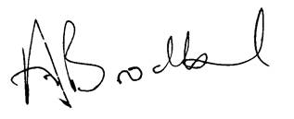 Dated 27th July 2026

